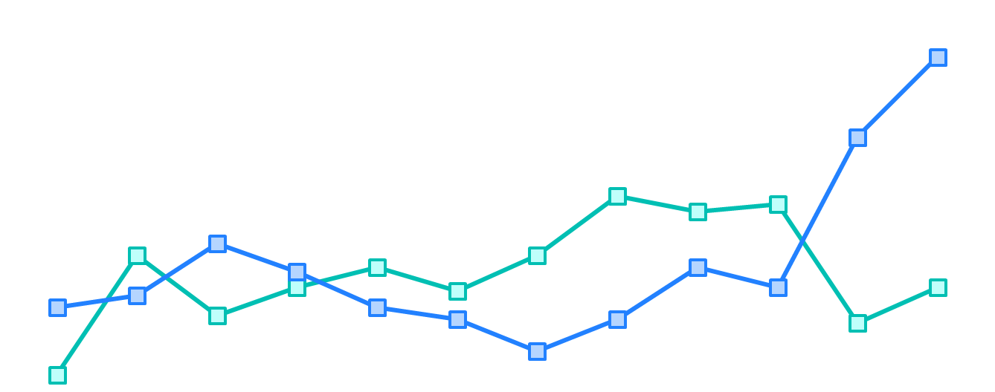

**2021 TRB Innovations in Transit Performance**

**Measurement Challenge**

*This 3rd Annual Challenge is sponsored by the Transportation Research Board (TRB) Transit Management and Performance Committee and the Transformative Trends in Transit Data Committee.*

**Objective**

The challenge aims to advance the use of data by transit agencies to inform decisions and encourage professionals, students, and academics to participate in TRB. Submitters are encouraged to develop and share innovative methods to analyzing data and communicating results. With sharing “best practices” in analyzing data in the transit industry, other agencies can apply the lessons learned, approaches, and methodologies. We believe measuring and managing performance with data is important to the success of transit agencies. We welcome diversity and encourage submissions from outside of the US/Canada, young people, people of color, and others not typically heard at TRB.

**Data Description**

Submitters may choose to utilize public transportation data available within the agency he/she/they works; data that they have access to through their projects (with the appropriate approvals); or data that they have collected/licensed specifically for the challenge. Alternatively, submitters are welcome to utilize publically-available data via API/GTFS feeds.

**Challenge Format**

Submissions will be evaluated by Committee representatives and a select group of finalists will be invited to participate in the 2021 Challenge at the TRB Annual Meeting. At the Annual Meeting, selected finalists will make a 5-minute presentation and present during a poster session. Winners will be announced live at the TRB Annual Meeting (virtual conference).

**Timeline**

* **~~August 1, 2020~~ September 1, 2020-** Submissions are due
* **October 1, 2020 -** Selected finalists are invited to present at the 2021 TRB Annual Meeting
* **December 1, 2020 -** Selected finalists are required to submit additional resources
* **January 2021 -** 2021TRB Annual Meeting (virtual conference means no travel budget required!)

**What to Submit**

Email the name of your point of contact and a zip file by ~~August 1, 2020~~ **Sept. 1, 2020** to [transitperformancechallenge@gmail.com](mailto:transitperformancechallenge@gmail.com) containing the following:

1. *An innovative data visualization tool.*

Submitters are encouraged to use interactive visualization tools, but are not required to do so. Submissions can be a dashboard, report, application, storyboard, PowerPoint or something else. The submitter must ensure that the selected data visualization tool is fully-functional and viewable using common software or a free reader.

1. *A narrative write-up limited to 6 pages that answer the following questions:*

* What problem does the data analysis seek to address? Who is your audience?
* What data source was utilized and why? How often should the data be updated?
* What analysis methods or approaches were applied? What are the results?
* How can this data visualization tool help a transit agency improve?
* What features or capabilities of the tool make it special?
* How can you implement your data visualization tool at scale?

*Every submission should include a primary contributor and if applicable, additional contributors. Please include the full names of the contributors, their respective organizations and their contact information.*

**After the review of the received submissions is complete, the selected finalists will be notified by October 1, 2020 and invited to present at the January 2021 TRB Annual Meeting in Washington, DC.**

The Committee will ask selected finalists to provide the following by December 1, 2020:

1. *A presentation that concisely demonstrates your innovative data visualization tool and highlights your narrative write-up responses. During the presentation, each finalist will be limited to one (1) speaker, six (6) slides, and five (5) minutes.*
2. *A poster that summarizes the data visualization tool and addresses the responses from the narrative write-up.*

For this challenge, TRB will provide each finalist with a 30 inch (76.2 cm) high by 40 inch (101.6 cm) wide blank foam core board and an easel to display their poster. The core board can also be rotated to accommodate a 40 inch (101.6 cm) high by 30 inch (76.2 cm) wide poster. Push pins will be provided as well. For those who are interested in bringing computers to display your visualization, we suggest that you bring a laptop or tablet (tables will be provided).

**If needed, Committee representatives will be available for a one 30-minute call in preparation for the January 2021 TRB Annual Meeting.**

**Winners will be announced during the January 2021 TRB Annual Meeting in Washington, DC.**